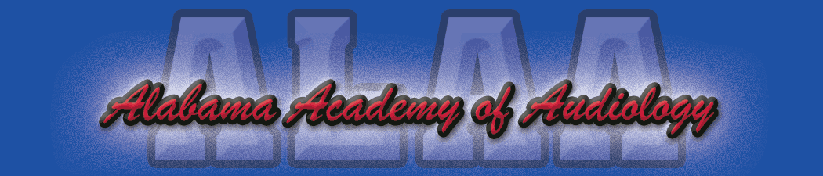

Alabama Academy of Audiology Convention 2024 Exhibitor Registration Form
Due April 30, 2024

Company Name: _____________________________________________________________________________

Address: ____________________________________________________________________________________

Contact Person: ______________________________________________________________________________

Phone: __________________________ E-mail: ____________________________________________________

Exhibiting Representative(s): __________________________________________________________________

Please select one of the following:

- Platinum Sponsorship Level $1950

Includes: Exhibitor Table, 45-minute technology Forum slot*, 1 team member registration for CEUs ($350 value)
Additional registration $200 for CEUs (save $150)

- Gold Sponsorship Level $1,700

Includes: Exhibitor Table, continental breakfast or lunch sponsored, 1 team member registration for CEUs ($350 value)
Additional registration $200 for CEUs (save $150)

- Silver Sponsorship Level $ 1,450
Includes: Exhibitor table, 1 team member registration for CEUs ($350 value)
Additional registration $200 for CEUs (save $150)

- In addition to the sponsorship fees, I would like to donate an item for the Blind Auction/President’s Reception on Thursday night. A board member will contact me regarding my donation.

*Please note: Technology Forum slots are limited and are on a first come basis only after payment is received.

Please return registration form and check made payable to Alabama Academy of Audiology to:

Britiany Pierson, Au.D.
C/O ALAA Convention
1846 Edgehill Dr.
Hueytown, Al 35023

Feel free to contact Carrie Overschmidt, Au.D. at carrie.overschmidt@gmail.com or Bobby McClung, Au.D. at bobby_mcclung@outlook.com for additional information. Many thanks for your continued support of the Alabama Academy of Audiology!

