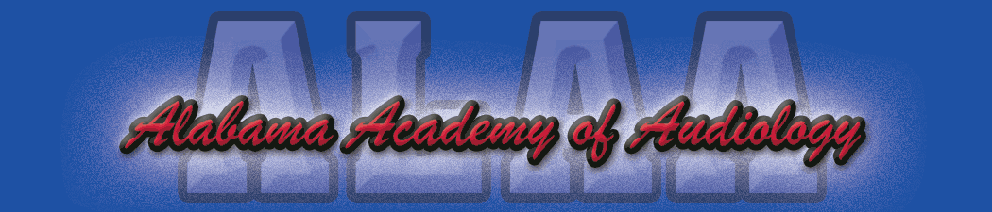

Alabama Academy of Audiology Convention 2022 Exhibitor Registration Form
Due May 31, 2022

Company Name: _____________________________________________________________________________

Address: ____________________________________________________________________________________

Contact Person: ______________________________________________________________________________

Phone: __________________________ E-mail: ____________________________________________________

Exhibiting Representative(s): __________________________________________________________________

Please select one of the following:

- Platinum Sponsorship Level $1,750.00
Exhibitor Table
45 minute technology Forum slot*

- Gold Sponsorship Level $1,500.00
Exhibitor Table
Sponsor a continental breakfast or lunch

- Silver Sponsorship Level $ 1250.00
Exhibitor table

- State Government or Non-Profit Organization $ 350.00
Exhibitor table

*Please note: Technology Forum slots are limited and will only be assigned only after payment is received on a first come basis.

- In addition to the sponsorship fees, I would like to donate an item for the Blind Auction/President’s Reception on Thursday night. A board member will contact me regarding my donation.

Please return registration form and check made payable to Alabama Academy of Audiology to:

Britiany Pierson, Au.D.
C/O ALAA Convention
1846 Edgehill Dr.
Hueytown, Al 35023

Feel free to contact Carrie Overschmidt, Au.D. at carrie.overschmidt@gmail.com or Bobby McClung, Au.D. via email at bobby_mcclung@outlook.com for any additional information if needed.

Many thanks for your continued support of the Alabama Academy of Audiology!

