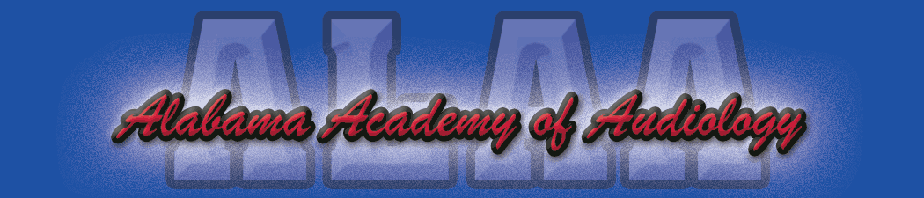

You are cordially invited to attend the 2018 Alabama Academy of Audiology Convention to be held at the beautiful Sandestin Hilton Resort on September 27-28, 2018. We will be offering 13.5 hours of continuing education (9 of which are Tier I activities) that are in the accreditation process by both the American Academy of Audiology and the Alabama Board of Examiners for Speech Pathology and Audiology. I think that you will find that we are offering a variety of topics that should appeal to everyone. Please check our website at alaudiology.org for full conference details.

We have secured a block of rooms at a reduced rate at the Sandestin Hilton Resort. The deadline for the special rate is August 27, 2018. Make sure that when calling to reserve a room that you mention that you are attending the ALAA Convention. Should you have any questions or concerns, please feel free to contact any of our board members. We look forward to seeing you at the beach in September.

Aaron Johnson, Au.D., CCC-A
ALAA President

