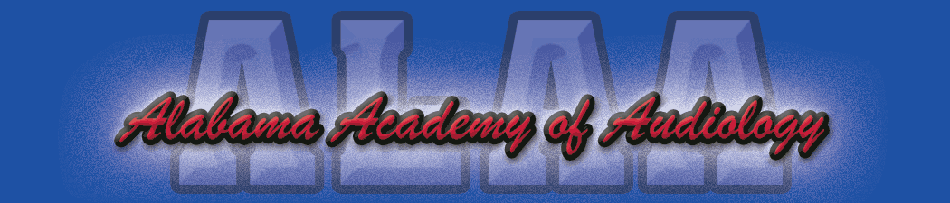

Alabama Academy of Audiology Convention 2017 Sponsorship Fees
Due June 15, 2017

Platinum Sponsorship Level ($1,500):
- Exhibitor Table.
- Technology Forum (30 minutes).
- Sponsor a continental breakfast or lunch.

Gold Sponsorship Level ($1,250):
- Exhibitor Table.
- Technology Forum (30 minutes).

Silver Sponsorship Level ($1000):
- Exhibitor table.
- Sponsor a continental breakfast or lunch.

For those wishing to secure an exhibit table only, the cost for two days will be $750.00.

****If you are interested in sponsoring the Blind Auction/President’s Reception on Thursday night please contact a board member.

Please remit your payments along with your sponsorship level to Britiany Pierson, Au.D. C/O ALAA Convention, 846 Edgehill Dr. Hueytown, Al 35023. Should you have any additional questions or concerns please feel free to contact Wilder Roberts, Au.D. (wilderroberts@southalabama.edu).

Many thanks for your continued support of the Alabama Academy of Audiology.

