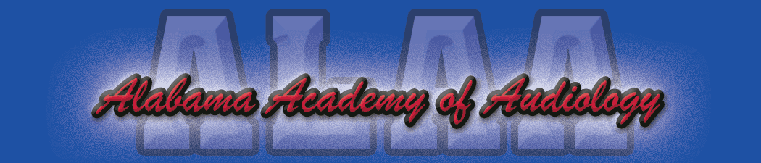

Alabama Academy of Audiology Convention 2017 Sponsorship FORM
Due June 15, 2017

_____ Platinum Sponsorship Level ($1,500):
- Exhibitor Table.
- Technology Forum (30 minutes).
- Sponsor a continental breakfast or lunch.

_____ Gold Sponsorship Level ($1,250):
- Exhibitor Table.
- Technology Forum (30 minutes).

_____ Silver Sponsorship Level ($1000):
- Exhibitor table.
- Sponsor a continental breakfast or lunch.

_____ Exhibit table only ($750.00)

Time slots for presenters will be given based on order of payment received. Upon receipt of payment, you will be contacted immediately with your presentation options. Please remit your payments along with your sponsorship level to Britiany Pierson, Au.D. C/O ALAA Convention, 846 Edgehill Dr. Hueytown, Al 35023. Should you have any additional questions or concerns please feel free to contact Wilder Roberts, Au.D. (wilderroberts@southalabama.edu).

Thank you for your continued support of the Alabama Academy of Audiology.

